8.65: a) To throw the mass sideways, a sideways force must be exerted on the mass, and hence a sideways force is exerted on the car. The car is given to remain on track, so some other force (the tracks on the car) act to give a net horizontal force of zero on the car, which continues at 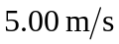east.
b) If the mass is thrown with backward with a speed of relative to the initial motion of the car, the mass is at rest relative to the ground, and has zero momentum. The speed of the car is then 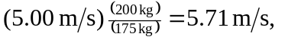and the car is still moving east.

c) The combined momentum of the mass and car must be same before and after the mass hits the car, so the speed is 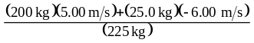=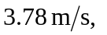with the car still moving east.

